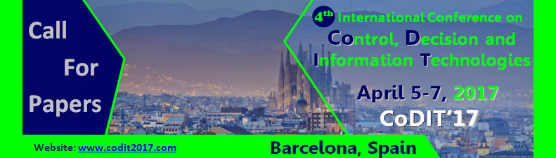
Special Session

CALL FOR PAPERS
SPECIAL SESSION ON
“Special Session Title”
for CODIT’17
April 5-7, 2017 – Barcelona, Spain

Session Co-Chairs :
Prof. Enrique H. Viedma, University of Granada, Spain
Prof. Belkacem Ould-Bouamama,, University of Lille 1, France
Session description
This special session deals with the problem of ………………………………………………………………………………………… …………………………………………………………………………………………………………………………………………………………………………………………………………………………………………………………………………………………………………
The goal is to…………………………………………………………………………………………………………………………………………… …………………………………………………………………………………………………………………………………………………………………………………………………………………………………………………………………………………………………………
The topics of interest include, but are not limited to:
- …
- …
- …

SUBMISSION
Please submit your full paper choosing the right Special Session (01-Special Session: #Title of your proposed Special Session#) on the EasyChair for CoDIT'17 website:
https://easychair.org/conferences/?conf=codit17
All papers must be written in English and should describe original work. The length of the paper is limited to a maximum of 6 pages (in the standard IEEE conference double column format).
IIMPORTANT DATES
December 4, 2016: deadline for paper submission
February 2, 2017: notification of acceptance/reject
February 26, 2017: deadline for final paper and registration.

